Project Design Phase
Solution Architecture

Date | 08 March 2025
Team ID
Project Name | Cab Booking
Maximum Marks | 4 Marks

Solution Architecture:
Solution architecture describes how different components of the system interact to solve the business problem. For the Smart Cab Booking System, the architecture connects passengers, drivers, and the backend server through a web or mobile application.
The main goal of the system is to provide fast, secure, and reliable cab booking services by using modern technologies such as GPS tracking, cloud databases, and real-time communication between users and drivers.
The architecture helps in defining how the application will handle user requests, driver availability, ride booking, payment processing, and data storage.

Main Components of the System
1. User Interface (Passenger App / Web App)
This is the interface where passengers interact with the system.
Users can:
- Register and log in
- Enter pickup and drop locations
- Book a cab
- Track the driver in real time
- Make online payments
- Rate and review drivers
2. Driver Interface (Driver App)
Drivers use this interface to:
- Register and log in
- Accept or reject ride requests
- View passenger pickup location
- Navigate to the destination
- Update ride status
3. Application Server
The backend server processes all requests from passengers and drivers.
It performs the following tasks:
- Matching passengers with nearby drivers
- Managing ride requests
- Processing payments
- Handling user authentication
- Managing ride history and data
4. Database
The database stores all system data such as:
- User information
- Driver details
- Booking history
- Payment records
- Ratings and reviews
5. GPS and Location Services
GPS services are used to:
- Detect the real-time location of drivers
- Show the nearest available cabs
- Track the ride during the trip
6. Payment Gateway
A secure payment gateway allows users to make payments using:
- UPI
- Debit/Credit cards
- Digital wallets

System Workflow (Data Flow)
- The passenger opens the application and enters pickup and destination locations.
- The system detects nearby available drivers using GPS.
- A ride request is sent to the nearest driver.
- The driver accepts the request.
- The passenger can track the driver in real time.
- After reaching the destination, the payment is processed through the payment gateway.
- The ride details and feedback are stored in the database.

Benefits of the Architecture
- Efficient matching between passengers and drivers
- Secure data storage and payment processing
- Real-time location tracking
- Scalable system that can support many users simultaneously
- Improved reliability and performance of the cab booking service

Example - Solution Architecture Diagram:
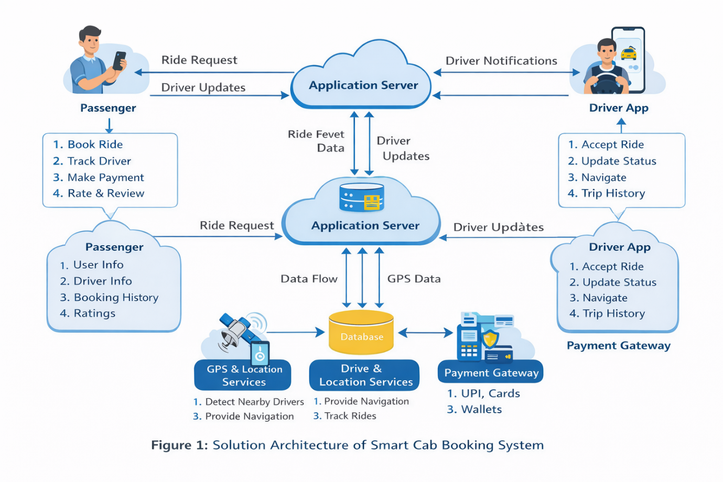

Figure 1: Architecture and data flow of the voice patient diary sample application
Reference: https://aws.amazon.com/blogs/industries/voice-applications-in-clinical-research-powered-by-ai-on-aws-part-1-architecture-and-design-considerations/

